Archbishop Francis Leo Visits St. Gregory the Great and Holy Cross Parishes in Durham
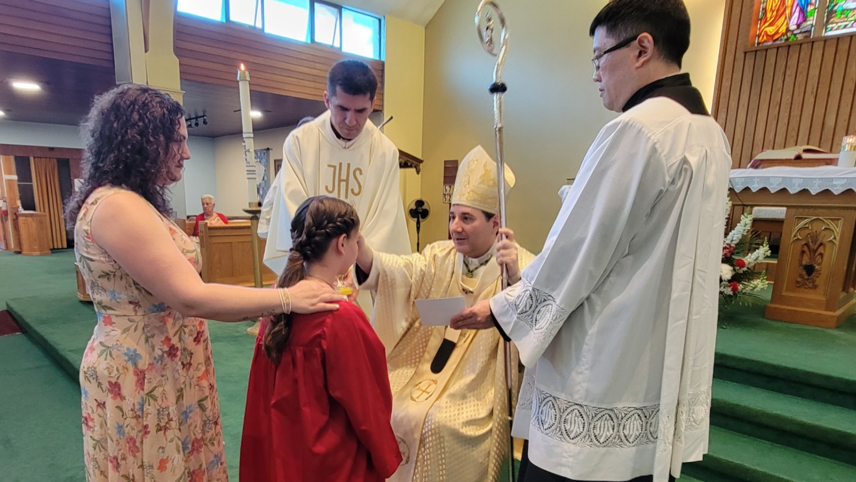

On Sunday, May 26, 2024, the Most Reverend Francis Leo, Archbishop of Toronto, travelled to St. Gregory the Great Church and Holy Cross Church in Oshawa to celebrate a Mass at each Parish and administer the Sacraments of First Communion and Confirmation to 68 young Parishioners.

It was a great day of spiritually joyous celebration for both Parish communities as they joined together to pray for these young people receiving these special gifts.

The archbishop shared in his homily words of hope and resilience with the youth. He especially thanked the parents for their encouragement and commitment to attending Mass on Sunday and urged them to continue to lead their children to grow in their faith journey with Jesus Christ and His Church.

Toward the end of the Mass, one of the confirmands thanked the archbishop for coming to celebrate these special Sacraments with them. One of the first communicants presented the archbishop with a small gift of appreciation.

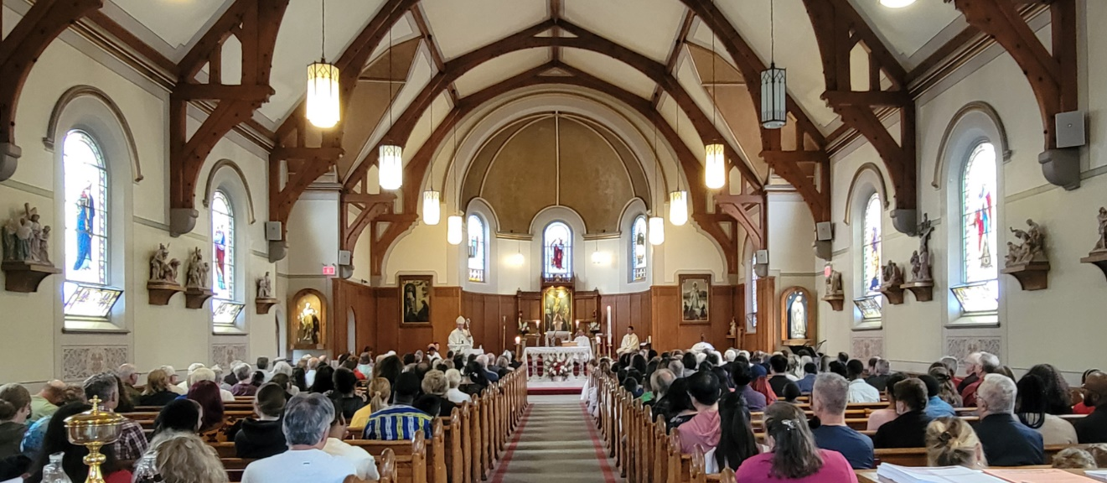
About St. Gregory's Parish

St. Gregory the Great is the mother Parish of all Catholic Parishes in this area. Thus, in 1843, 181 years ago, St. Gregory the Great was the first Parish established in the newly created Diocese of Toronto. It was the first seed to be sown in an area now covered by the Region of Durham.

The 50th anniversary of St. Gregory’s Parish in 1852 was celebrated with fanfare and a visit from Archbishop Walsh, who, during his sermon, made a strong plea for contributions to the building fund for a new church.

Father M.J. Jeffcott was the pastor who supervised the construction of the new St. Gregory’s Church at the present location. Archbishop Walsh laid the Cornerstone on June 18, 1893. Therefore, St Gregory's church celebrates 130 years of its existence. The Parish continued to grow thanks to the many pastors who dedicated themselves, their time, and energy lovingly to God and their Parishioners and the many renovations the church underwent.

It is difficult to imagine that this historic edifice at the crossroads of busy Oshawa city streets was once a forest clearing with a simple log church dedicated to St. Gregory the Great. From there to a frame church and finally a brick structure, St. Gregory the Great Catholic Church continues to be a major positive influence and landmark in and around Oshawa. As the Parish strengthened by the power of Christ, we continue to serve lovingly God and all we meet, especially those with greater needs in the wider community.

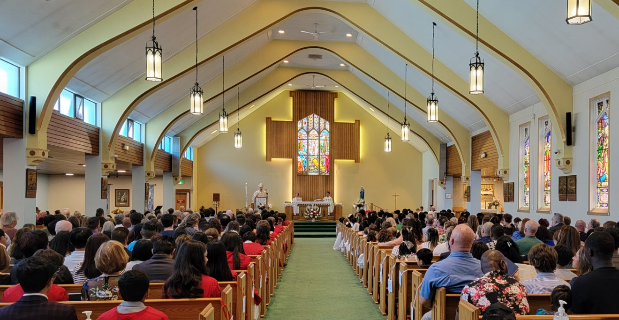
About Holy Cross Parish

Holy Cross, the second Catholic Parish in Oshawa, was erected on June 20, 1939, with the appointment of Rev. Philip Coffey as its first pastor. Due to its proximity to the neighbourhood where many ethnic communities were founded, Catholic immigrants of mostly Polish, Croatian, Italian and other ethnic backgrounds attended Masses at Holy Cross.

Holy Cross underwent many renovations throughout the years thanks to the dedicated work of the many pastors and community members. This September 14, 2024, the Parish will celebrate its 85th Anniversary with a Mass followed by the Parish BBQ.

Although the ethnic origin of its Parishioners has changed, Holy Cross continues to be a vibrant community that is always welcoming new members and visitors. It is a small community with a big heart that continues to provide many services for the community it serves.

The two Parishes are currently being administered under the pastoral guidance of Fr. Marijan Sisko who celebrates Masses at both Parishes.

Finally, we are grateful to God for the many years of goodness and faithfulness to His people in our two Parishes, for the 85th anniversary of Holy Cross Parish, and the 130th anniversary of St. Gregory's church. It was beautiful to welcome our Archbishop Francis among us. We joyously witnessed our children receiving the First Holy Communion, and our young people being 'sealed with the gift of the Holy Spirit' in the Sacrament of Confirmation. May our Parishes continue to be 'the salt of the earth' (Matt 5:13), and "may God continue to bless us" (Ps 67:7), now and always.

